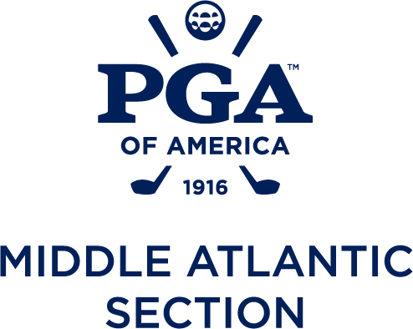

2026 Middle Atlantic PGA Tournaments

April 13th Stroke Play #1 Links at Perry Cabin- Saint Michaels, MD
May 4th Four-Ball Montgomery CC - Laytonsville, MD
May 11th Senior Junior Champ Evergreen CC – Haymarket, VA
May 18th Britt Sloan Scramble Salisbury CC- Midlothian, VA
April 20th or June 1st Pro-President TBD
Date TBD Pro-Scratch TBD
June 8th – 9th Senior Match Play Loudoun G & CC- Purcellville, VA
June 29th-30th Match Play Chartwell G & CC - Severna Park, MD
July 6th SOVA Last Chance Spring Creek GC – Zion Crossroads, VA
August 3rd Pro-Junior Woodmont CC- Rockville, MD
August 4th Women’s Championship Mt. Vernon CC- Alexandria, VA
August 11th-12th Assistant’s Championship CC of Maryland- Towson, MD
August 17th Stroke Play #2/ Head Pro Golden Horseshoe GC- Williamsburg, VA
August 24th – 25th Senior Championship Keswick Club - Keswick, VA
September 14th – 16th Section Championship Hayfields CC- Hunt Valley, MD
October 19th-20th Players Cup Birdwood GC - Charlottesville, VA
October 26th-27th Team Championship Bay Creek Resort – Cape Charles,Bay Creek GC - Cape Charles, VA

2026 Chapter Tournaments

Central Chapter
March 30th Central Chapter Spring Pro-Pro Springfield G&CC
May 26th Central Chapter Championship Lansdowne Resort
Sept 8th Central Chapter Pro-Assistant 1757 GC

Northern Chapter
April 6th Northern Chapter Spring Pro-Pro Rolling Road GC
May 26th Northern Chapter Championship TBD
Date TBD Northern Chapter Fall Pro-Pro TBD

Southern Chapter
March 30th Southern Chapter Spring Pro-Pro Fredericksburg CC
May 26th Southern Chapter Championship Williamsburg GC
September 21st Southern Chapter Fall Pro-Pro Lakeside GC

